Самостоятельная работа №2.

**Инвариантная часть.**

**Задача №1.**

**Постановка задачи:**



**Код программы:**

procedure TForm1.Button1Click(Sender: TObject);

var x,y,i,n,r,cx,cy: integer;

a,b: real;

begin

n:=StrToInt(Edit1.Text);

Image1.Canvas.clear;

with Image1.Canvas do begin

Pen.Color:=clwhite;

Brush.Color:=clwhite;

Brush.Color:=clwhite;

FillRect(0,0,Width,Height);

Rectangle(0,0,Width,Height);

a:=2*pi/3;

r:=round(Width/3);

cx:=round(Width/2);

cy:=round(Height/2);

for i:=1 to n do

begin

Pen.Color:=RGBToColor(random(255),random(255),random(255));

r:=r-15;

x:=cx+r;

y:=cy;

MoveTo(x,y);

b:=a;

while b<=2*pi do

begin

x:=round(cx+r*cos(b));

y:=round(cy+r*sin(b));

LineTo(x,y);

b:=b+a;

end;

end;

end;

end;

**Результат:**

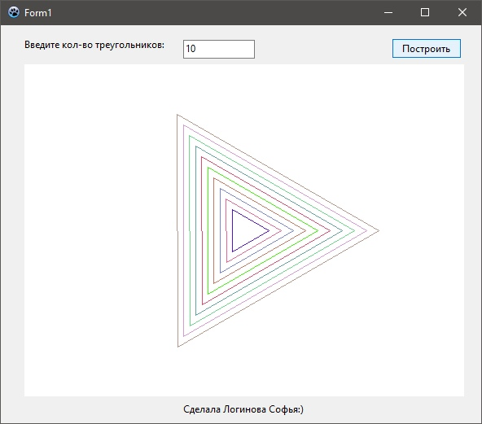

**Задача №2.**

**Постановка задачи:**

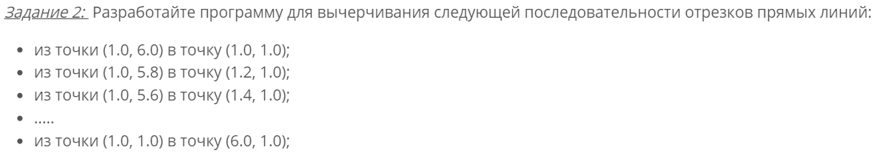

**Код программы:**

procedure TForm1.FormCreate(Sender: TObject);

var x1, y1, x2, y2: integer;

begin

with Image1.Canvas do

begin

Pen.Color:= clNavy;

Brush.Color:=clwhite;

Rectangle(0,0,Width,Height);

FillRect(0,0,Width,Height);

x1:= 100;

y1:= 600;

x2:= 100;

y2:= 100;

MoveTo(x1,y1);

LineTo(x2,y2);

while x2<600 do

begin

x2:=x2+20;

y1:=y1-20;

MoveTo(x1,y1);

LineTo(x2,y2);

end;

end;

end;

**Результат:**

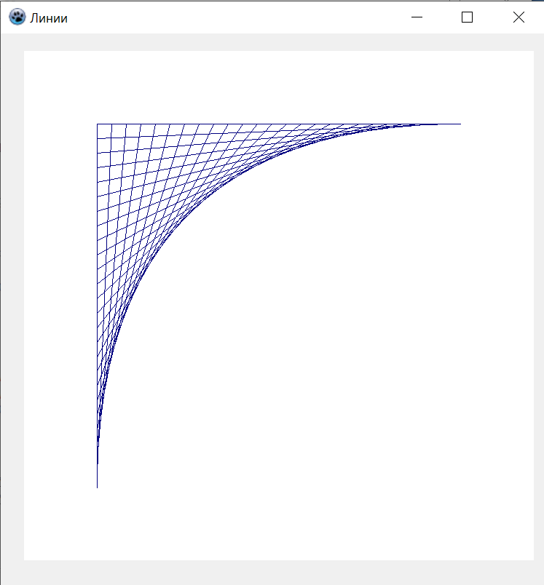

**Вариативная часть.**

**Задача №3**

**Постановка задачи:**



**Код программы:**

procedure TForm1.Button1Click(Sender: TObject);

var u,i,y,z,d: integer;

treug: array [1..3,1..3] of integer = ((5,20,0),(75,150,0),(150,20,0));

begin

u:=StrToInt(Edit1.Text);

u:=round(2*pi*u/360);

with Image1.Canvas do

begin

Pen.Color:=clwhite;

FillRect(0,0,Width,Height);

Rectangle(0,0,Width,Height);

Pen.Color:=clgray;

MoveTo(0,round(Height/2));

LineTo(Width,round(Height/2));

MoveTo(round(Width/2),0);

LineTo(round(Width/2),Height);

MoveTo(Width,0);

LineTo(0,Height);

Pen.Color:=clred;

for i:=1 to 3 do

begin

y:=treug[i,2];

z:=treug[i,3];

treug[i,2]:=round(y*cos(u)-z*sin(u));

treug[i,3]:=round(y*sin(u)+z*cos(u));

end;

for i:=1 to 3 do

begin

d:=treug[i,3]*round(sin(pi/4));

treug[i,1]:=round(Width/2)+treug[i,1]-d;

treug[i,2]:=round(Width/2)-treug[i,2]+d;

end;

MoveTo(treug[3,1],treug[3,2]);

for i:=1 to 3 do LineTo(treug[i,1],treug[i,2]);

end;

end;

**Результат:**

